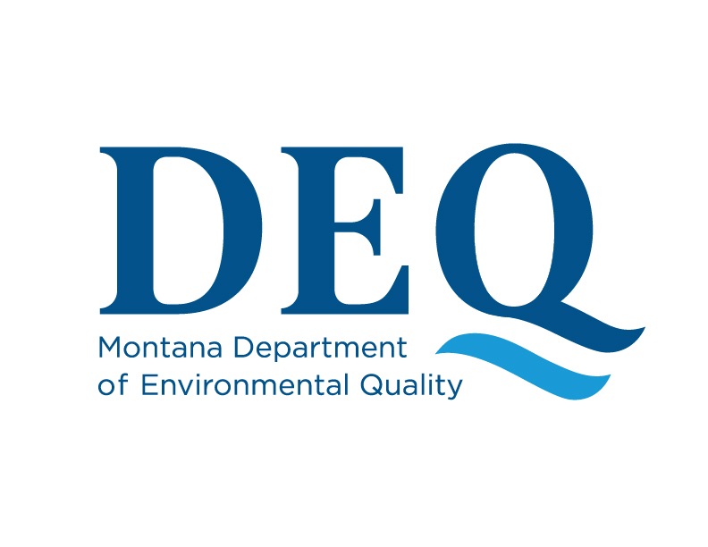
For Official Use Only
Permit #

Air, Energy & Mining Division

Operating Permit Applicant - Certification of Compliance
Hard Rock Mining Operating Permit No.

Sections 82-4-335(8) and (9), Montana Code Annotated (MCA) of the Metal Mine Reclamation Act provide the requirements for a person’s eligibility to be issued a Hard Rock Operating Permit by the Department of Environmental Quality (the Department). The person (Applicant) is responsible for completing the certification document set forth below and returning the document to the Department, prior to submission of a bond and the Department’s issuance of a final permit.

(Agent) as (Title) of (Applicant) of (Address) hereby certify:

- I am a duly authorized agent of the Operating Permit Applicant (Applicant) for Hard Rock Operating Permit No. .

- The Applicant agrees to conduct the mining operation in full compliance with the terms and conditions of the permit and expressly assumes the duty to complete reclamation of land disturbed under the operating permit pursuant to the requirements of the Metal Mine Reclamation Act.

- The Applicant, or any firm or business association of which the Applicant was a principal or controlling member, has not previously failed to comply with the provisions of the Metal Mine Reclamation Act, the rules adopted under the Metal Mine Reclamation Act, or a permit or license issued under the Metal Mine Reclamation Act that has resulted in either receipt of bond proceeds by the Department of Environmental Quality or the completion of reclamation by the surety or by the Department of Environmental Quality, unless the conditions described in Section 82-4-360 are met.

- The Applicant has not failed to pay a penalty for which the Department of Environmental Quality has obtained a judgment pursuant to Section 82-4-361, MCA.

- The Applicant has not failed to post a reclamation bond required under the Metal Mine Reclamation Act.

- The Applicant has not failed to comply with an abatement order issued pursuant to Section 82-4-362, MCA, unless the Department of Environmental Quality has completed the abatement and the Applicant has completed the abatement and the Applicant has reimbursed the Department of Environmental Quality for the cost of abatement.

- I certify that (select one):

☐ a) that the Applicant is not currently in violation in this state of any law, rule, or regulation of this state or the United States pertaining to air quality, water quality, or mined land reclamation, or;

☐ b) the administering agency certifies that the violation is in the process of being corrected to the agency’s satisfaction or is the subject of a bona fide administrative or judicial appeal, and

☐ a copy of the certification is attached hereto.

- If the Applicant is a partnership, corporation, or other business association, I certify that (select one):

☐ a) no officers, directors, owners of 10% or more of any class of voting stock, partners or other business association members of the Applicant are currently in violation in this state of any law, rule, or regulation of this state or the United States pertaining to air quality, water quality, or mined land reclamation, or;

☐ b) the administering agency certifies that the violation is in the process of being corrected to the agency’s satisfaction or is the subject of a bona fide administrative or judicial appeal, and

☐ a copy of the certification is attached hereto, or;

☐ c) Not applicable, Applicant is not a partnership, corporation, or other business association.

_______________________________ ______________________
Applicant Signature Date

